



Model answer of Fundamentals of Nursing
Final Semester Exam – code (nur 101)
First Year- First Term
Date: 9 /1/2016 Time allowed: 3 hours
Questions parts: 4 No. of papers: 9 total marks: 80 marks
Section I:Multiple Choice Questions: ( 20 marks)
*Please circle the correct answer only :
1- A client has been on prolonged bed rest, and the nurse is observing for signs associated with immobility. In assessment of the client, the nurse is alert to a (an):
a) Increased blood pressure
b) Decreased heart rate
c) Increased urinary output
d) Decreased peristalsis
2- Concept of disease should include:
a) A pathological change in physical, mental and social fitness
b) A pathological change in the structure or function of body or mind with specific symptoms
c) Physical, mental and social not being.
d) None of the above.
3- Subjective data might include:
a) Abnormal lab results
b) Feelings of anxiety
c) Elevated temperature.
d) None of the above
4- The most important purpose of cleansing bed bath is:
- To cleanse, refresh and give comfort to the client who must remain in bed
- To expose the necessary parts of the body
- To develop skills in bed bath
- To check the body temperature of the client in bed
5 - A nurse obtained a client’s pulse and found the rate to be above normal. The nurse documents these findings as:
a) Tachypnea c) Tachycardia
b) Hyporpyrexia d) Hyperpyrexia
6- The nurse is preparing to take vital sign in an alert client admitted to the hospital with dehydration secondary to vomiting and diarrhea. What is the best method used to assess the client’s temperature?
- Oral c) Axillary
- Rectal d) Heat sensitive tape
7-What intervention would be most appropriate for a client with mild hypothermia?
a)Applying blankets
b)Applying an electronic hypothermia blanket
c)Administering warmed intravenous fluids
d)Providing a warm air temperature
8-The blood pressure of a 50-year-old client is 168/100. Which nursing action is most appropriate?
a)Referring the client to a physician
b)Rechecking the blood pressure in one week
c)Advising the client to go to the emergency room
d)Rechecking the blood pressure annually
9-Vertical or horizontal columns for recording dates and times to show assessment and intervention
a)Flow sheet b)Reporting
c)Kardex d)Focus charting
10-All the following purpose of documentations Except
a)Communication b)Legal evidence
c)Research & education d)Chart omission
11-The following steps to assess oxygenation and circulation needs Except
a)Level of conciseness b)Blood pressure
c)Breath sound d)Tubes used to instill or drain fluid
12- Narrative charting is:
a) A chronologic account written in paragraphs by each member of health care team on a separate documentation
b) A chronologic account written in paragraphs that describe client's status
c) A structured, logical format & focuses on the client's problem
d) System using a column format to chart data, action, and response
13- Acute illness:
- Mostly life threatening with life
- Need medical treatment & life adjustments
- Is of slow onset
- Its symptoms suddenly developed

14- Drug allergic reactions are adverse reactions occur related to
a) High doses of drugs
b) Prior contact with the drugs that act as antigens
c) Chronic use of drugs
d) Withdrawal of some drugs

15- PRN order indicates that
a) Drug will be given only once
b) Order of drug can be carried out for a specified number of days or until another order cancels
c) Drug can be administered as needed
d) Doctor is not available to write & sign the order such as in an emergency
16- Factors affecting drug action are
a) Body weight
b) Nutritional factors
c) Genetic and environment factors
d) All of the above
17- Types of drug order are all o the following Except:
a) Standing order
b) PRN order
c) One time and telephone order
d) Delayed order
18- The fourth stage of illness is a stage in which ………
- The symptoms persists & it needs medical intervention
- The person is a real patient that needs help& assistance from health care providers
- The person will recognize that something is wrong & he will complain from certain symptom that does not exist before
- The recovery and rehabilitation stage of the disease usually started at the hospital
19- Data are collected from a variety of sources; however, client should be considered
a) Secondary source
b) Primary source
c) Tertiary source
d) All the above
The benefits of the nursing process for the client is-20
a) Job satisfaction
b) Participation in their own care and continuity of quality care.
c) Professional growth
d) Self-confidence
Section II: Please, read the statement carefully and write the letter (T) if the statement is true and the letter (F) if the statement is false. ( 15 marks)
Item | True/False
1- WHO defines health as state of complete physical, mental and social wellbeing, not merely the absence of disease?
2- Acute appendicitis is considered chronic illness
3- Immunizations is example of primary prevention.
4- Common skin problems include abrasion& corn
5- Gingivitis is inflammation of the gums.
6- Hypertension is blood pressure above normal (above 140/90)
7- Hyperapnea: Is inability to breath or difficulty in breathing while lying in a horizontal position
8- Pyrexia: Is body temperature above the normal range.
9-The reservoir is a person who lacks resistance to an agent and is thus vulnerable to disease
10- The Z-track is a method used in subcutaneous injections
11-The function of feedback is to provide the sender with information about the receiver’s perception of a situation.
12-Palliative therapy is used for patients with end stage or terminal diseases
13- Maintenance therapy is based on practical experience rather than pure scientific data
14- The infectious agent is only a biological agent that invade the host
15- After administering heparin you should massage the injection site

1 | 2 | 3 | 4 | 5 | 6 | 7 | 8 | 9 | 10 | 11 | 12 | 13 | 14 | 15
t | f | f | f | t | t | f | f | f | f | t | t | f | f | f

Section III: Matching Type Questions ( 20 marks )
Part 1 : Match the definition in column A with the correct word in column B
Column A |  | Column B
- Surgical asepsis |  | - The entry and multiplication of an organism in a host
- Medical asepsis |  | - Sterile technique, sterile object touching sterile object, any object that enters body/penetrates skin (wound, injections, caths, IVs) must be sterile
- Infections |  | - Procedures to prevent and control infection and its spread. Gloves, mask, eyewear (when splash or splatter can occur).
- Asepsis |  | - Known as "clean technique", includes procedures used to reduce the number of organisms present and prevent the transfer of organisms.
- Standard precautions |  | - The absence of pathogenic (disease-producing) microorganisms
1 | 2 | 3 | 4 | 5
b | d | a | e | c
Part II
Column I |  |  | Column II
6- Sites of intramuscular injection are |  |  | a- Forearm, upper arm, or across the scapula.
7- Intramuscular injections may be contraindicated in patient with |  |  | b- Neuromuscular disorder, esophageal strictures, mouth lesions.
8- The usual sites of intradermal injections |  |  | c – Deltoid, dorsogluteal, ventogluteal, vastus lateralis.
9- Oral administration is contraindicated in patient with |  |  | d- Upper arm, around umbilicus, thigh, scapulae
10- Sites of subcutaneous injection |  |  | e – Occlusive peripheral vascular disease, edema, shock.
6 | 7 | 8 | 9 | 10
c | e | a | b | d

Part III:
Column I |  | Column II
11-Receiver |  | a-Messages stem from a person’s need to relate to others, to create meanings, and to understand various situations
12-Channel |  | b-A stimulus produced by a sender and responded to by a receiver.
13-Sender |  | c-The information the sender receives about  the receiver’s reaction to the message
14-Feedback |  | d-The person who intercepts the sender’s message.
15-Message |  | e- The medium through which a message is transmitted
11 | 12 |  | 13 | 14 | 15
d | e |  | a | c | b
Part IV:
Column I |  | Column II
16- Reporting |  | a. It takes the precedence of overall others because they are essential for survival
17- Kardex |  | b. Process used for handling off critical information about the patient to other individuals who will be involved in the care of patient
18- Physiological needs |  | c. Data base, problem list, initial plan and progress notes
19- Safety and security |  | d. Is a summary work sheet reference of basic client care information that traditionally is not a part of the medical record
20- Component of POMR |  | e. Takes the next priority after physiological needs
16 | 17 |  | 18 | 19 | 20
b | d |  | a | e | c

Section IV: Essay (25 marks)
1-Factors that increase the risk of being a susceptible host )6 marks)
- Age, (the very young and the very old are more likely to get an infection).
- High level of stress from work, lack of rest and emotional stress can affect the body's ability to defend itself from pathogens.
- Poor nutrition (either malnutrition or chronic obesity).
- Preexisting diseases ( cancer or chronic lung disease)
- Surgical treatment.
- Certain medications and medical treatment (chemotherapy for cancer)
- Indwelling medical devices such as catheter, feeding tubes, intravenous lines, increase a person's risk of infection by making it easier for pathogens to enter the body
2- Major communication channels (3 marks)
- The visual channel → is sight, observation, and perception.
- The auditory channel → consists of spoken words and cues.
- The kinesthetic channel → refers to experiencing sensations.

3- Nursing responsibilities for medication administration : (6 marks)
1-Assessment of the patient and clear understanding of why the patient is receiving a particular medication.
2- Preparing the medication to be administered.
3- Accurate dosage calculations.
4- Administration of the medication.
5- Documentation of medications given.
6- Monitoring the patient's reaction and evaluating the patient's response.
7- Educating of the patient regarding his or here medications and medication regimen.

4- Nursing care for patient with hypothermia: (5 marks)
•If the patient is wet, remove the wet cloths and replace them with dry ones.
•Warp the client in blankets.
•Give him hot fluids to drink.
•Place the client near a fire or in a warm room.
•Place heating pads next to areas of the body
5- Factors causing variation in respiration: (5 marks)

Factors causing variation in respiration:
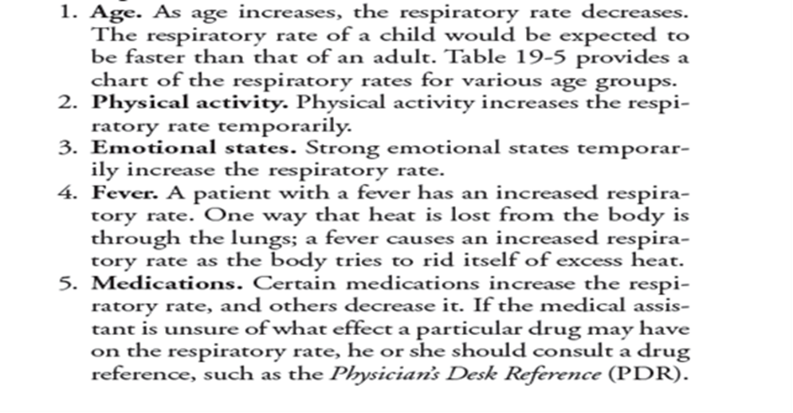

End of questions

Good luck

